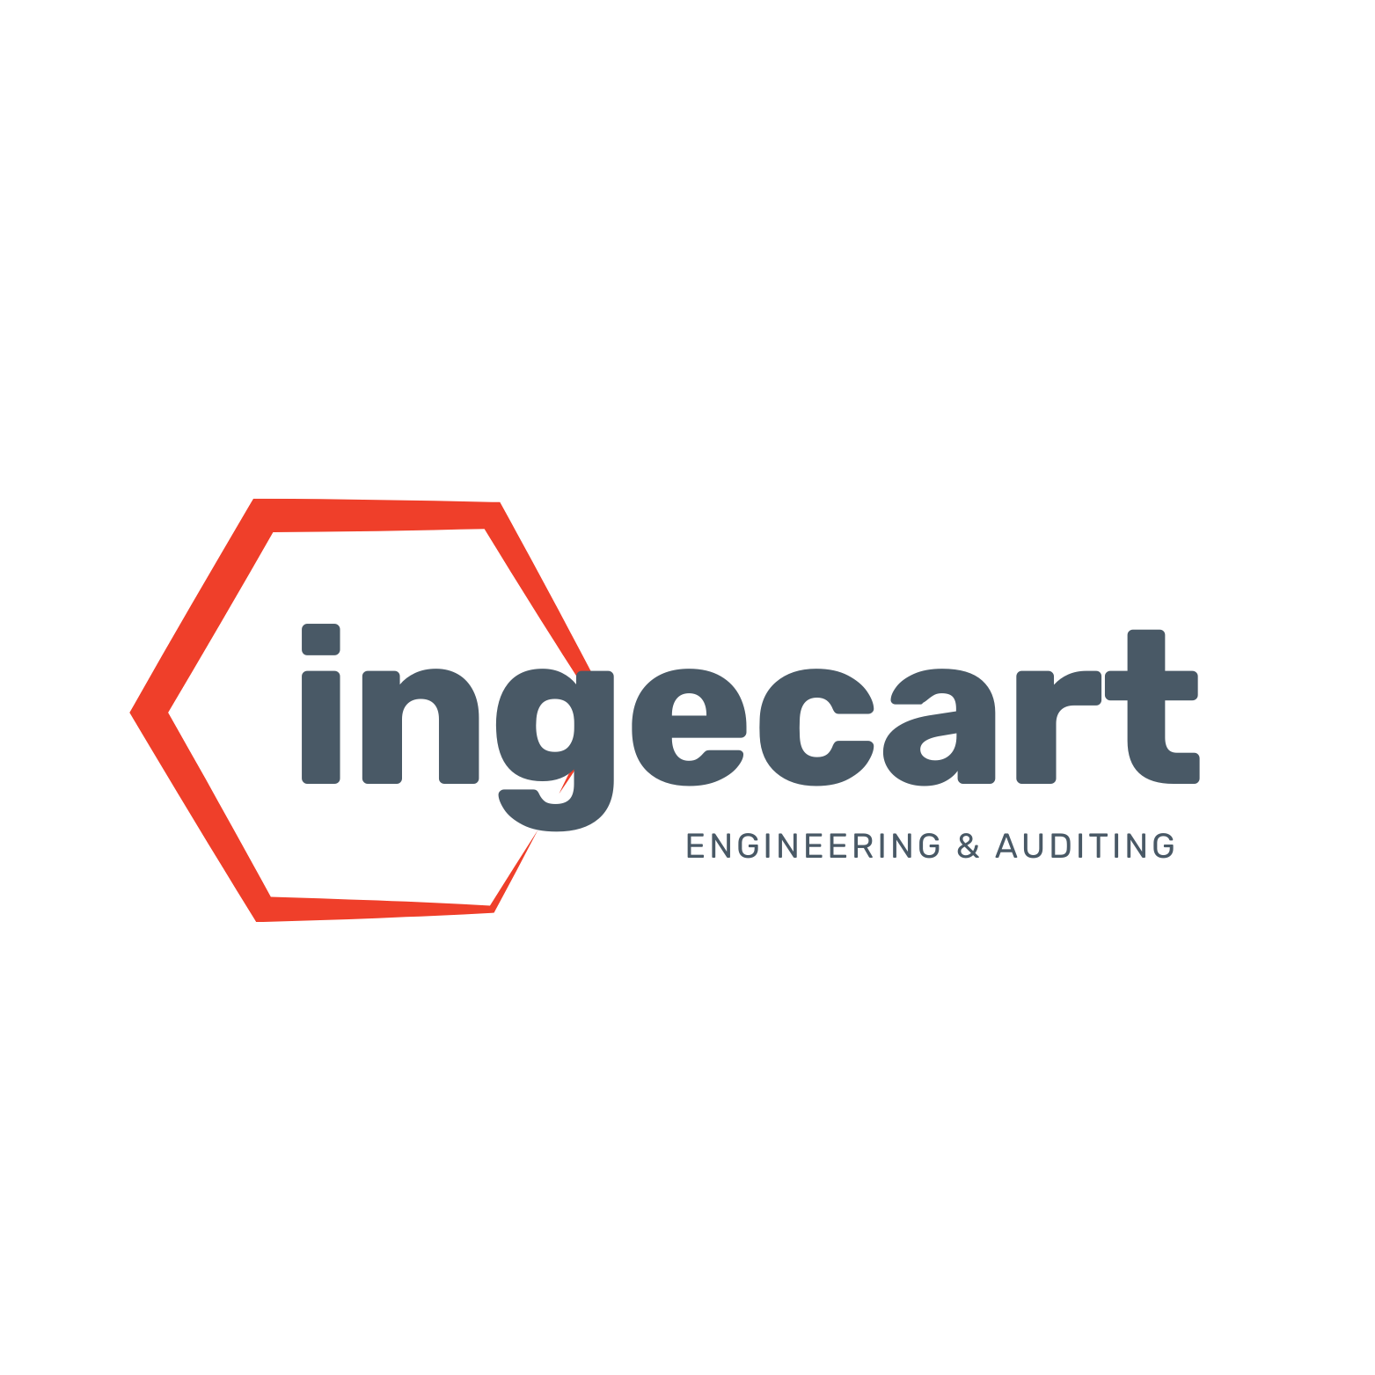
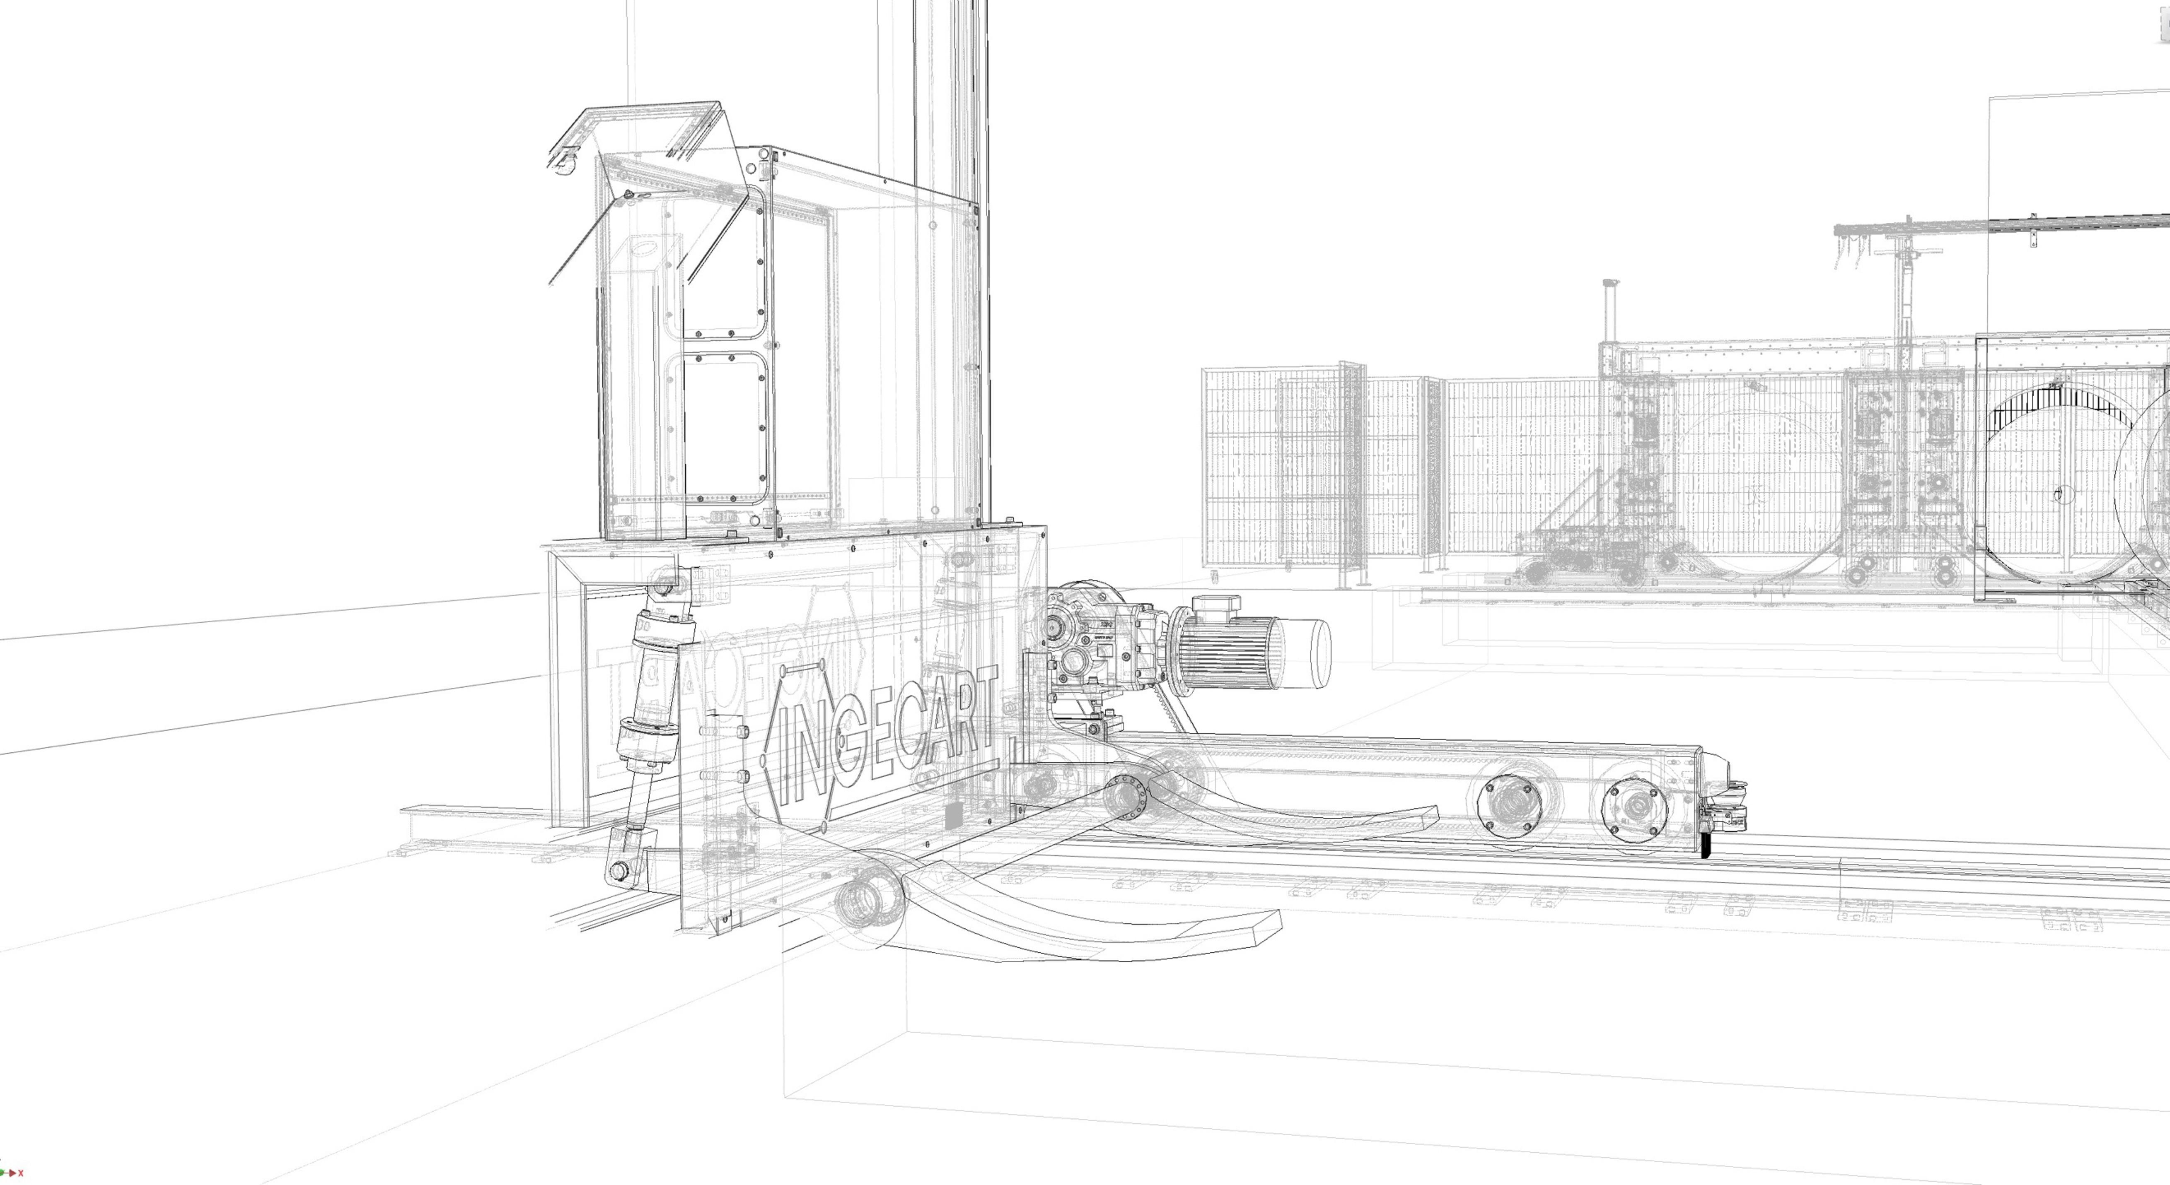

Client: Cascades Calgary
Project: Phase 1 - TRANSFER & CONVEYOR Package
OFF-2026-135

Offer summary

Cascades Calgary - Phase 1: Transfer & Conveyor Package
This proposal covers the installation of a coordinated transfer and conveyor package for the conversion area. The new design introduces automated transfer flows between the three RDC outputs and the second-pass equipment or final shipment line.
The package includes the following equipment and operating logic:
- Automatic transfer car / shuttle system between the three RDC outlets.
- Automated conveyors synchronized under INGECART control software.
- Automatic delivery to the FG miniline and Automatic Two-Piece Folder Gluer & Stitcher line.
- Automatic routing to the final shipping conveyor.
- Interface with the current production management system and plant signal logic.

Operating Concept
The existing manual transfer operations are replaced by a coordinated automatic flow. Each RDC output is connected to an automated conveyor controlled through the same management software. The transfer car moves product from right to left and directs material to the second-pass machines or to the shipping conveyor, eliminating operator dependency at the critical discharge points.
Preliminary Sketch
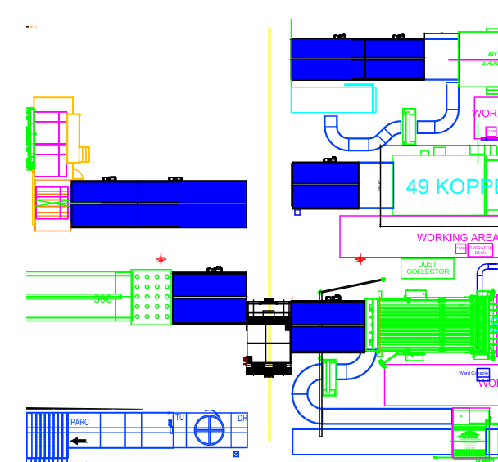

Technical Data
Transfer car / automatic shuttle:
- Maximum load capacity: 3,000 to 5,000 kg.
- Lateral travel speed: 1.5 to 2.5 m/s.
- Roller bed speed: 0.3 to 0.5 m/s.
- Usable bed width: 1,800 to 2,800 mm.
- Usable bed length: 3,000 to 5,500 mm.
- Transport height: 300 to 450 mm.
- Positioning accuracy: ±2 mm to ±5 mm.

Typical PLC Inputs and Outputs
Inputs:
- Load position sensors
- Safety scanner / laser area detection
- Encoder / telescope laser distance for exact position
- Fixed-line load and discharge requests
- End-of-travel switches
Outputs:
- Drive direction and speed command
- Roller bed control
- Brake actuation
- Signal tower alarm command
- Interlock release to the fixed line
- Equipment status and system interface signals

Scope and Commercial Proposal

Package | Price
Transfer & Conveyor | €476,059
Engineering & Prioritization | $95,000 USD (~€87,500)
Equipment, installation and commissioning | Remainder of agreed scope

The complete package is proposed with equipment, installation and travel included. Taxes, transport and packaging are excluded.

Commercial Conditions
The equipment remains property of INGECART until full payment is received.
Offer validity: as defined in the proposal. Payment terms: as defined in the proposal. Delivery time: approximately 9 months from INGECART Barcelona, plus transport and installation.
The offer excludes works and materials not specifically described, project utilities not included in the scope, transport and packaging, and any additional labor with customer-requested extra time, which will be charged separately.

General Sales Conditions
1. Scope of application and precedence.
2. Industrial and intellectual property remains with INGECART.
3. Price and payment conditions.
4. Delivery deadlines and notice period.
5. Retention of title and insurance.
6. Transport, packaging and cargo insurance.
7. Commercial and technical warranty.
8. Limitation of liability.
9. Force majeure.
10. Jurisdiction and applicable law.

Signature
For and on behalf of INGECART
Signature: ______________________
Name: Diego García
Date: ________________________

